Refer to Lecture 2 on Cells and fill out this worksheet. Please upload it to Canvas for a completion grade and bring it to class to take notes on Thursday (10/03/24). We will go over the assignment in class.

Q1. The three domains of life are: BACTERIA , ARCHAEA , and
EUKARYA Circle the prokaryote domains.

Q2. Fill in the table with the characteristics of Prokaryotes and Eukaryotes:

 | Prokaryote | Eukaryote | Things in common
Nucleus | NONE, dna in cytoplasm | Present, dna in nucleus | Cell membrane, dna, ribosomes, ability to divide, reproduce, cytoplasm
Organelles | NONE | Present, mitochondira, chloroplasts, endoplasmic reticulum, golgi apparatus, etc
Chromosomes | One circular chromosome (no histones) | Multiple linear chromosomes (histones)
Cell wall | yes | Yes,
Cell division | Binary fission | Complex - mitosis
Average generation time | Shorter, could be 20 min | Longer, could be 24 hours
Cell size | Smaller < 2 micrometers | Larger, 2-100 micrometers

Q3. What are the items in the sketch below? What do they do? Fill in the table below.
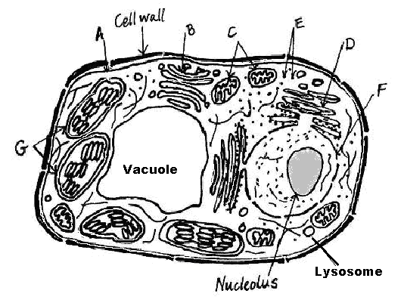
Label | What is it? | What does it do/ what happens there?
- | Cell wall | Provides structural support and protection to the cell
- | Nucleolus | Produces and assembles the cells ribosomes
A | Cell membrane | External cell barrier, helps with transport of things in and our of cell, has receptors on it to signal what can and cant enter cell.
B | Golgi apparatus | Packages modifies and distinguishes proteins to be shipped out of the cell
C | mitochondria | Powerhouse of the cell, atp synthesis
D | Endoplasmic retiuculum | Packaging proteins to be shipped to the golfi apparatus, synthesizes phospholipids and choleseterol, sugar groups attached to proteins
E | vesicles | packages things to be moved around the cell?
F | nucleus | Control center, transmits genetic info and provides instruction for protein synthesis
G | chloroplast | Site of photosynthesis
- | Lysosome | Used to clean up waste in the cell/intracellular digestion
- | Vacuole | Used to store ions, waste products, pigments, or protective compounds

Q4. What sort of cell is this? PLANT CELL

Q5. Why do plant cells have a central vacuole and animal cells don’t?
ANSWER: mainly for water storage and for rigidity and cell structure. Animals can seek out water whereas plants are more limited in their ability to receive water (rain). They must store water and nutrients and also have internal pressure to keep their shape and structure needed for growth.

Q6. What are some organelles that contain internal compartmentalization? How do internal compartments assist in the functioning of the organelle?
ANSWER: ER, golgi apparatus, mitochondria, lysosomes, chloroplasts. These are membrane enclosed organelles and allow for the organelle to contain distinct biochemical reactions specific to its function. It helps the organelle maintain a more unique and specific environment pertaining to its function.

Q7. Which organelles have their own DNA? Compare their functions. Define their origins?
ANSWER: Mitochondria and chloroplasts have their own DNA. The mitochondria exists in both plant and animal cells but chloroplasts only exist in plant cells. The chloroplast is the site of photosynthesis and the mitochondria is the site of atp synthesis. They both originate from ancient bacteria and were cells that were engulfed by another cell through endosymbiosis, which is why they have their own DNA.

Q8. In measurement of length, what are the longest cells (when mature) in the human body? What fundamental property of all cells is denied to these?
ANSWER: Neurons are the longest cells when mature in the human body and they are denied the ability to divide!

Q9. What is the structure of the cell membrane and define 5 of it’s functions.
ANSWER: A cell membrane is a phosphor lipid bilayer with proteins embedded in int. There are hydrophilic heads with hydrophobic tails. Some of its functions are transport, enzymatic activity, signal transduction, intercellular joining, cell cell recognition, and attachment to the cytoskeleton.

Q10. What is the composition of cell walls in bacteria vs plants?
ANSWER: In bacteria cell walls are made of sugars and amino acids but in plants cell walls are made of cellulose and chitin.

